Project Design Phase-II
Technology Stack (Architecture & Stack)

Date | 03 October 2026
Team ID | SWTID-2026-5432
Project Name | ServiceNow Employee Data Import using Transform Maps
Maximum Marks | 4 Marks

Technical Architecture:
This deliverable presents the architecture and technology stack for importing employee information from a spreadsheet into ServiceNow using Import Sets, validation, Transform Maps, and coalesce. The design includes staging, target employee records, and reporting.
Scenario: Spreadsheet-based employee data import and record maintenance
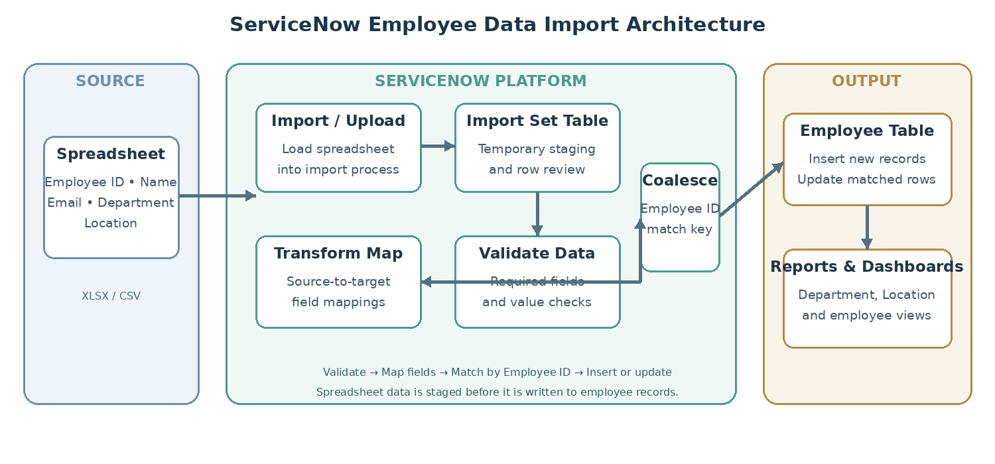
Workflow: Spreadsheet → Import Set Table → Validate → Transform Map → Employee Table → Reports & Dashboards
Guidelines:
Include all the processes (As an application logic / Technology Block)
Provide infrastructural demarcation (Local / Cloud)
Indicate external interfaces (third party API’s etc.)
Indicate Data Storage components / services
Indicate interface to machine learning models (if applicable)


Table-1 : Components & Technologies:
S.No | Component | Description | Technology
1. | User Interface | Administrator selects and uploads the employee spreadsheet, reviews staged rows, runs transforms, and views reports. | ServiceNow web UI / Import Set interface
2. | Application Logic-1  Import Processing | Receives spreadsheet rows and loads employee data into a temporary import set for processing. | ServiceNow Import Sets
3. | Application Logic-2  Validation | Checks required fields such as Employee ID, Name, and Email; flags incomplete or invalid rows for correction. | Import set validation / transform scripts (if configured)
4. | Application Logic-3  Transformation & Coalesce | Maps source columns to target fields and matches existing employees by Employee ID to update or insert records. | ServiceNow Transform Maps / Coalesce
5. | Database  Target Records | Stores finalized employee records with Employee ID, Name, Email, Department, and Location. | ServiceNow Employee table (target table)
6. | Cloud Database  Staging | Temporarily stores uploaded spreadsheet rows before validation and transformation. | ServiceNow Import Set Table
7. | File Storage | Holds the uploaded spreadsheet during the import workflow; exact retention/storage configuration is instance-dependent. | ServiceNow attachment/import file storage
8. | External API-1 | No external API is specified in the provided use case. | Not applicable / not specified
9. | External API-2 | No second external API is specified in the provided use case. | Not applicable / not specified
10. | Machine Learning Model | No machine-learning model is required or specified for this import workflow. | Not applicable
11. | Infrastructure  (Server / Cloud) | Runs the import, staging, transformation, employee table, and reporting within the ServiceNow environment. | ServiceNow instance / managed platform; deployment details depend on organization

Table-2: Application Characteristics:
S.No | Characteristics | Description | Technology
1. | Open-Source Frameworks | The described workflow uses native ServiceNow import capabilities; no separate open-source framework is identified in the use case. | ServiceNow Import Sets and Transform Maps
2. | Security Implementations | Restrict import and employee-table access to authorized roles; apply table/field ACLs and platform encryption controls where enabled. Validate data before writing target records. | ServiceNow roles, ACLs, platform security and encryption settings (confirm per instance)
3. | Scalable Architecture | Import processing is organized into staging, validation, transformation, and target-data layers. Capacity and batch sizing should be configured for the expected spreadsheet volume. | ServiceNow platform; import batch/transform configuration
4. | Availability | The workflow runs within the organization's ServiceNow instance. Availability depends on the ServiceNow service and the organization's instance configuration and operational practices. | ServiceNow platform availability; instance/service commitments
5. | Performance | Keep spreadsheets to the required columns, validate early, use Employee ID consistently as the coalesce key, and monitor transform duration and row errors. Performance targets are not specified. | Import Set / Transform Map execution; indexed or unique Employee ID where supported and configured

References:
https://c4model.com/
https://developer.ibm.com/patterns/online-order-processing-system-during-pandemic/
https://www.ibm.com/cloud/architecture
https://aws.amazon.com/architecture
https://medium.com/the-internal-startup/how-to-draw-useful-technical-architecture-diagrams-2d20c9fda90d

